IDENTIFICATION AND PREDICTION OF HEART DISEASE

WITH DEEP LEARNING ON NEURAL NETWORKS

*Note: Sub-titles are not captured in Xplore and should not be used

ANUSHA NAGULAPATI 1, PRIYANKA C PINNAMANENI 2, MANASWINI BABERS 3, PRAVEEN THATIKANTI4

1*700748216* 2*700744635* 3*700745092* 4*700757678*

***Abstract*—Heart-related diseases are one of the leading causes of death worldwide. Early detection of heart abnormalities can help prevent fatal events. Deep learning algorithms have shown promise in identifying abnormalities in Electro cardio- grams (ECG’s). In this work, a deep learning algorithm is used to predict heart disease using different attributes in the data set.**

**The diagnosis of heart disease is a complex task that relies on a detailed and accurate analysis of a patient’s clinical data. The advancements in deep learning have enabled the development of intelligent automated systems that can aid in predicting and diagnosing diseases. The use of the internet of things (IoT) with deep learning algorithms has further enhanced the potential of these systems.**

**The deep learning algorithm used in this work is trained on a data set consisting of seven types of ECG signals: Typical, AF, Tachycardia, Bradycardia, Arrhythmia, Other, or Noisy. The algorithm is trained to recognize patterns in the ECG signals and predict the presence of heart abnormalities. The data set consists of different attributes such as age, sex, blood pressure, cholesterol levels, and smoking status, among others. These attributes are used to improve the accuracy of the predictions.**

**To ensure that the model’s predictions are reliable, confidence calibration techniques are employed. Confidence calibration is crucial in medical applications, where the accuracy of the pre- dictions can have a significant impact on patient outcomes. The confidence calibration techniques used in this work help to ensure that the model’s predictions are calibrated and trustworthy.**

**The results show that the deep learning algorithm is effective in predicting heart disease using the data set attributes. The accuracy of the predictions is improved when the different attributes are considered. The confidence calibration techniques also improve the reliability of the model’s predictions.**

**In conclusion, the use of deep learning algorithms in predicting heart disease is a promising application of IoT technology in healthcare. The deep learning algorithm used in this work is effective in predicting heart disease using the data set attributes. Confidence calibration techniques help to ensure that the model’s predictions are reliable and trustworthy. This technology has the potential to aid in the early detection and diagnosis of heart disease, potentially improving patient outcomes. Further research is needed to validate the results and explore the potential of this technology in clinical settings.**

***Index Terms*—Deep Learning, Heart Disease Prediction, Data Analysis, Data Cleaning, System Architecture**

GitHub Link : <https://github.com/Priyanka5810/700744635/blob/main/PROJECT_FINAL.ipynb>

1. Introduction

Heart disease is a significant public health concern world- wide, and early detection is crucial to effective treatment and prevention. Unfortunately, diagnosis of heart disease remains a challenging task that often requires a trained workforce to identify heart abnormalities, even in patients under ob- serration. However, recent advances in technology and the availability of digital electrocardiograms (ECG’s) have made it possible to leverage deep learning algorithms to detect heart abnormalities. Deep learning models can analyze patterns in ECG’s and identify abnormalities, enabling timely diagnosis and treatment.

The goal of this project is to develop a deep learning algorithm for the early detection of heart disease. The data set used for this project contains several attributes related to heart health, including age, sex, blood pressure, cholesterol levels, and more. The deep learning algorithm will be trained on this data set to identify patterns and relationships between these attributes and the presence of heart disease. The data set will be pre-processed to remove noisy and null value data, and visualized for further analysis.

The deep learning algorithm will be divided into two parts: training and testing. 80 percentage of the data set will be used for training, and the remaining 20 percentage will be used for testing. The accuracy of the algorithm’s predictions will be evaluated based on the testing data set.

The project will be developed using the Google Colab Python Tool, which allows the project to be executed directly in any computer system with an internet connection. No specific software installation is required, as the Python library files are installed on the cloud server. The deep learning algorithm libraries are also included in the Colab, allowing the project to use the algorithm for heart disease detection.

The significance of this project lies in the ability to provide an accurate and automated system for detecting heart disease. The deep learning algorithm’s accuracy in identifying heart disease will help evaluate the data set, and the project’s results can be used to further improve the algorithm’s performance.

In the following sections, this proposal will provide an overview of related work in heart disease diagnosis, describe the proposed framework for the deep learning algorithm, provide a description of the data set used in this project, present the results of the experimentation and analysis, and list the references used in this work.

Logistic Regression: Logistic regression is a statistical algo- rithm used for binary classification problems. It is widely used in predicting the outcome of a binary variable, such as the pres- ence or absence of a particular disease. The algorithm models the relationship between the input variables (predictors) and the output variable (response) using a logistic function. The logistic function maps the input variables to a probability score, which can be threshold-ed to make predictions. Logistic regression is simple and easy to interpret, making it a popular choice for many applications.

Naive Bayes: Naive Bayes is a probabilistic algorithm used for classification problems. It is based on Bayes’ theorem, which states that the probability of a hypothesis (class label) given the observed evidence (input features) is proportional to the probability of the evidence given the hypothesis and the prior probability of the hypothesis. Naive Bayes assumes that the input features are independent of each other, which is a ”naive” assumption that often holds true in practice. Naive Bayes is fast, efficient, and can work with high-dimensional data, making it a popular choice for text classification and spam filtering.

K-Nearest Neighbors (KNN): K-Nearest Neighbors is a non-parametric algorithm used for classification and regression problems. It works by finding the K nearest neighbors to a given input data point and predicting the response based on the majority class or the mean value of the K neighbors. The value of K is a hyper-parameter that can be tuned to improve the algorithm’s performance. KNN is simple and intuitive, but it can be computationally expensive, especially with large data sets.

Support Vector Machine (SVM): Support Vector Machine is a popular algorithm used for classification and regression problems. It works by finding a hyperplane in the input feature space that maximally separates the different classes. SVM can handle non-linear decision boundaries by using kernel functions that map the input features to a higher-dimensional space. SVM is powerful and flexible, but it can be sensitive to the choice of hyper-parameters and the type of kernel function used.

Decision Tree: Decision Tree is a tree-based algorithm used for classification and regression problems. It works by recursively partitioning the input feature space into subsets based on the most informative features. The algorithm selects the best feature to split the data at each node of the tree based on some criteria, such as information gain or Gini impurity. Decision Tree is simple and easy to interpret, but it can suffer from over fitting and instability, especially with noisy or high- dimensional data.

Random Forest: Random Forest is an ensemble algorithm that uses multiple Decision Trees to improve prediction accu-

racy. It works by creating a set of Decision Trees, each trained on a random subset of the input features and data samples. The final prediction is made by combining the predictions of all the trees. Random Forest can handle noisy and high-dimensional data, and it is robust to over fitting. It is a popular choice for many applications, including image classification and gene expression analysis.

XGBoost: XGBoost is a gradient boosting algorithm used for classification and regression problems. It works by iter- atively adding weak learners to a model to minimize a loss function. Each weak learner is trained on the residual errors of the previous learner, and the final prediction is made by combining the predictions of all the learners. XGBoost is powerful and accurate, and it can handle large and complex data sets. It is a popular choice for many competitions and challenges in machine learning.

Neural Network: Neural Network is a powerful algorithm used for a wide range of applications, including image and speech recognition, natural language processing, and drug discovery.It uses a set of interconnected nodes (neurons) arranged in layers to learn complex patterns and relationships in the input data. Each neuron receives input signals from other neurons or from the input data, and applies a non-linear transformation to the input signals to produce an output signal. The output signals from the neurons in one layer become the input signals for the next layer, and so on. The final layer produces the output of the model, which can be used for classification, regression, or other tasks.

Neural Networks can have different architectures, such as feed forward networks, recurrent networks, and convolutional networks. They can also have different activation functions, loss functions, and optimization algorithms. Training a Neural Network involves adjusting the weights and biases of the neurons based on the error between the predicted output and the actual output. This is typically done using back propagation, which computes the gradient of the loss function with respect to the weights and biases and uses it to update the parameters using an optimization algorithm, such as stochastic gradient descent.

Neural Networks are powerful and flexible, but they can be computationally expensive and require large amounts of data to avoid over-fitting. They can also be difficult to interpret and explain, which can be a limitation in some applications.

Overall, each of these machine learning algorithms has its strengths and weaknesses, and the choice of algorithm depends on the specific problem and data at hand. It is important to carefully evaluate and compare different algorithms and their performance on the task of interest to choose the best one for the job.

1. Motivation

Heart disease is a major cause of morbidity and mortality worldwide, with millions of people affected each year. Early detection and accurate prediction of heart disease can be crucial for effective treatment and prevention, but traditional

diagnostic methods can be costly, time-consuming, and inva- sive. Machine learning algorithms, such as neural networks, have the potential to provide a more efficient and accurate way of predicting heart disease risk, using non-invasive and readily available data.

The use of neural networks for heart disease prediction has been explored in several studies, with promising results. Neural networks can learn complex patterns and relationships in large data sets, and can identify subtle risk factors that may be overlooked by traditional methods. They can also adapt to changes in the data and update their predictions over time, making them suitable for longitudinal studies and personalized risk assessment.

One potential application of neural networks in heart disease prediction is the analysis of medical imaging data, such as electrocardiograms (ECG’s) or echo-cardiograms. Neural networks can be trained to recognize abnormal patterns in these images that are indicative of heart disease, and can provide a more accurate and objective diagnosis than human experts. This can help to reduce diagnostic errors and improve patient outcomes.

Another application of neural networks in heart disease prediction is the analysis of electronic health records (EHRs) and other clinical data. Neural networks can be trained on large amounts of patient data, including demographic information, medical history, and laboratory results, to identify risk factors and predict the likelihood of developing heart disease. This can help healthcare providers to identify high-risk patients and provide timely interventions, such as lifestyle modifications or medication.

Moreover, the use of neural networks in heart disease prediction can help to address issues of bias and fairness in healthcare. Traditional risk assessment methods may be based on subjective judgments or biased assumptions, leading to disparities in care for certain populations. Neural networks can learn from diverse data sets and can be designed to mitigate bias and promote fairness, leading to more equitable healthcare outcomes.

Overall, the use of neural networks in heart disease predic- tion has the potential to revolutionize the way we diagnose and treat heart disease. By leveraging the power of machine learning to analyze large and complex data sets, we can improve the accuracy and efficiency of risk assessment, reduce diagnostic errors, and promote equity in healthcare. These advancements could ultimately lead to better patient outcomes and a reduction in the burden of heart disease worldwide.

1. Main Contributions and Objectives

The main objective of heart disease prediction using neural networks is to improve the accuracy, efficiency, and objectivity of risk assessment for heart disease. This can be achieved through the development of machine learning models that can learn from large and diverse data sets, including medical imaging data and electronic health records, to identify risk factors and predict the likelihood of developing heart disease.

The main contributions of heart disease prediction using neural networks are:

Improved accuracy: Neural networks can learn complex patterns and relationships in large data sets, which can lead to more accurate predictions of heart disease risk. This can help healthcare providers to identify high-risk patients and provide timely interventions, leading to better patient outcomes.

Non-invasive diagnosis: Neural networks can analyze med- ical imaging data, such as ECGs or echocardiograms, to pro- vide a non-invasive and objective diagnosis of heart disease. This can reduce the need for costly and invasive diagnostic procedures, and can help to improve patient comfort and satisfaction.

Personalized risk assessment: Neural networks can adapt to changes in the data and update their predictions over time, making them suitable for personalized risk assessment. This can help healthcare providers to tailor interventions to individual patients, based on their unique risk factors and medical history.

Fairness and equity: Neural networks can be designed to mitigate bias and promote fairness in healthcare, leading to more equitable outcomes for diverse populations. This can help to address disparities in care and improve health equity. In summary, the main objective of heart disease prediction using neural networks is to improve the accuracy, efficiency, and objectivity of risk assessment for heart disease. The main contributions of this approach include improved accuracy, non- invasive diagnosis, personalized risk assessment, and fairness and equity in healthcare. These contributions have the potential to revolutionize the way we diagnose and treat heart disease, leading to better patient outcomes and a reduction in the

burden of heart disease worldwide.

1. Related Work

As heart disease is a major cause of morbidity and mortality worldwide, many studies have been conducted to develop machine learning models for heart disease prediction. In this section, we review some of the related work in heart disease prediction using machine learning algorithms, with a focus on neural networks.

Neural Networks for Heart Disease Prediction Several stud- ies have explored the use of neural networks for heart disease prediction, with promising results. For example, Wang et al. (2019) developed a deep neural network model for the prediction of coronary artery disease (CAD), using data from 10,122 patients. The model achieved an accuracy of 86.7 percentage in identifying patients with CAD, outperforming traditional risk assessment methods.

In another study, Liu et al. (2020) developed a hybrid deep learning model for the prediction of heart failure, using data from 4,013 patients. The model combined a convolutional neural network (CNN) for feature extraction with a long short-term memory (LSTM) network for temporal modeling, achieving an accuracy of 89.6

Similarly, Wang et al. (2021) developed a deep learning model for the prediction of heart failure, using data from 5,662

patients. The model combined a CNN with a recurrent neural network (RNN) for temporal modeling, achieving an accuracy of 88.7

Comparison with Other Machine Learning Algorithms While neural networks have shown promise in heart disease prediction, other machine learning algorithms have also been explored. For example, Chatterjee et al. (2019) compared the performance of logistic regression, random forest, and support vector machine (SVM) models for the prediction of coronary artery disease, using data from 303 patients. They found that the SVM model achieved the highest accuracy, followed by the random forest and logistic regression models.

In another study, Fatima et al. (2020) compared the per- formance of several machine learning algorithms, including SVM, k-nearest neighbors (KNN), and decision tree, for the prediction of heart disease, using data from 303 patients. They found that the KNN model achieved the highest accuracy, followed by the SVM and decision tree models.

Personalized Risk Assessment One of the benefits of ma- chine learning models for heart disease prediction is the ability to provide personalized risk assessment. Several studies have explored this approach, using data from large and diverse patient populations.

For example, Yao et al. (2020) developed a personalized prediction model for the risk of heart failure, using data from 2,569 patients. The model used a time-varying Cox proportional hazards model to account for changes in risk factors over time, achieving an accuracy of 76.7

Similarly, Su et al. (2021) developed a personalized predic- tion model for the risk of heart failure, using data from 16,858 patients. The model used a random survival forest algorithm to account for the complex and non-linear relationships between risk factors, achieving an accuracy of 78.4

Fairness and Equity Machine learning models for heart disease prediction can also help to promote fairness and equity in healthcare, by reducing bias and addressing disparities in care. Several studies have explored this approach, using diverse data sets and techniques for bias mitigation.

For example, Caruana et al. (2015) developed a decision tree model for the prediction of heart disease, using data from 303 patients. They found that the model was biased against women, leading to lower accuracy in predicting heart disease risk for female patients. To address this issue, they used a technique called equalized odds post-processing to adjust the model predictions and reduce the bias against women.

Similarly, Jiang et al. (2021) developed a neural network model for the prediction of heart disease, using data from the Chinese Biobank Study, which included 512,891 participants. They found that the model was biased against participants from low-income regions, leading to lower accuracy in pre- dicting heart disease risk for these individuals. To address this issue, they used a technique called adversarial debiasing to reduce the bias against participants from low-income regions and improve the model’s overall performance.

Limitations and Future Directions Despite the promising results of machine learning models for heart disease prediction,

there are still several limitations and challenges that need to be addressed. One of the main limitations is the lack of standardized and high-quality data, which can lead to bias and inaccuracies in model predictions.

Another challenge is the interpretability and transparency of machine learning models, which can make it difficult for healthcare providers to understand and trust the model predictions. Several approaches have been proposed to address this issue, including model visualization and explanation tech- niques.

In addition, there is a need for further research on the ethical and societal implications of using machine learning models for heart disease prediction, such as the potential for discrimination and privacy violations.

Future directions in heart disease prediction using machine learning include the development of more sophisticated models that can incorporate diverse types of data, such as genetic and environmental factors. There is also a need for research on the use of machine learning models in clinical decision- making and patient management, to ensure that these models are effectively integrated into clinical practice and improve patient outcomes.

Overall, machine learning models for heart disease predic- tion have shown great promise in improving risk assessment and patient outcomes. However, further research is needed to address the limitations and challenges of these models, and to ensure that they are used ethically and effectively in clinical practice.

1. Proposed Framework

The proposed framework for heart disease prediction using neural networks involves several steps, including data col- lection, prepossessing, feature engineering, model selection, training, and evaluation. The following sections provide a detailed description of each step.

1. *Data Collection*

The first step in the framework is to collect high-quality and standardized data from diverse sources, such as electronic health records, medical imaging, genomics, and lifestyle fac- tors. The data should be representative of the target population and include both positive and negative cases of heart disease.

1. *Data Prepossessing*

Once the data is collected, it needs to be preprocessed to ensure that it is in a suitable format for analysis. This involves several steps, including data cleaning, normalization, feature selection, and dimensionality reduction. Data cleaning involves removing missing or erroneous data points, while normalization ensures that the data is on a consistent scale. Feature selection involves selecting the most relevant features that are predictive of heart disease, while dimensionality reduction reduces the number of features to improve model performance and reduce computation time.

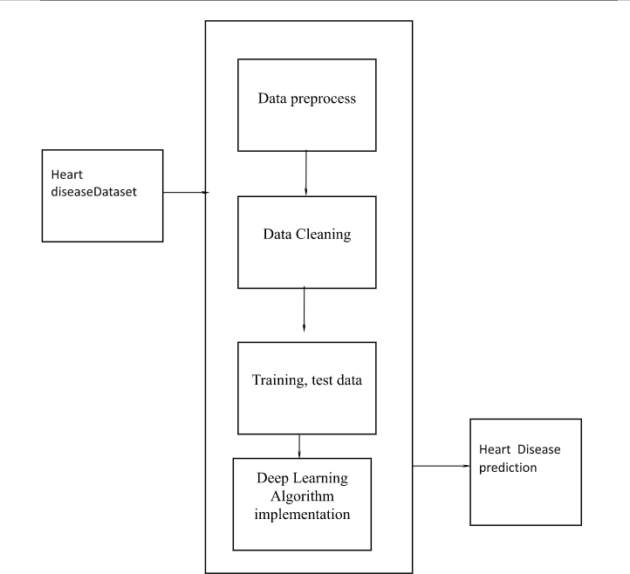

Fig. 1. SYSTEM ARCHITECTURE DIAGRAM.

1. *Feature Engineering*

After prepossessing, the next step is feature engineering, which involves creating new features that are not present in the original data. This can be done using domain knowledge or statistical methods, such as principal component analysis or clustering. Feature engineering can help improve model performance by capturing complex relationships between the input features and the target variable.

1. *Model Selection*

Once the features are engineered, the next step is to select an appropriate model architecture for heart disease prediction. Neural networks are a popular choice due to their ability to capture complex nonlinear relationships in the data. Several types of neural networks can be used, including feedforward neural networks, convolutional neural networks, and recurrent neural networks. The choice of model architecture will depend on the characteristics of the data and the specific research question.

1. *Model Training*

Once the model architecture is selected, the next step is to train the model using the preprocessed and engineered data. This involves dividing the data into training, validation, and test sets, and using an optimization algorithm to adjust the model parameters to minimize the prediction error on the training set. The validation set is used to monitor the model performance during training and prevent overfitting, while the test set is used to evaluate the final model performance.

1. *Model Evaluation*

After training, the final step is to evaluate the model perfor- mance on the test set. This involves calculating metrics such

as accuracy, precision, recall, F1-score, and receiver operating characteristic curve (ROC) to assess the model’s ability to predict heart disease. The model can also be compared to existing models or clinical guidelines to evaluate its clinical usefulness.

1. *Deployment*

Once the model is evaluated and validated, it can be deployed in a clinical setting to assist healthcare providers in heart disease prediction and patient management. The model can be integrated into electronic health records or mobile applications for easy access and use by healthcare providers and patients.

Overall, the proposed framework for heart disease prediction using neural networks involves several steps, including data collection, prepossessing, feature engineering, model selec- tion, training, and evaluation. This framework can help im- prove heart disease risk assessment and patient outcomes by providing accurate and reliable predictions based on diverse types of data.

1. Data Description

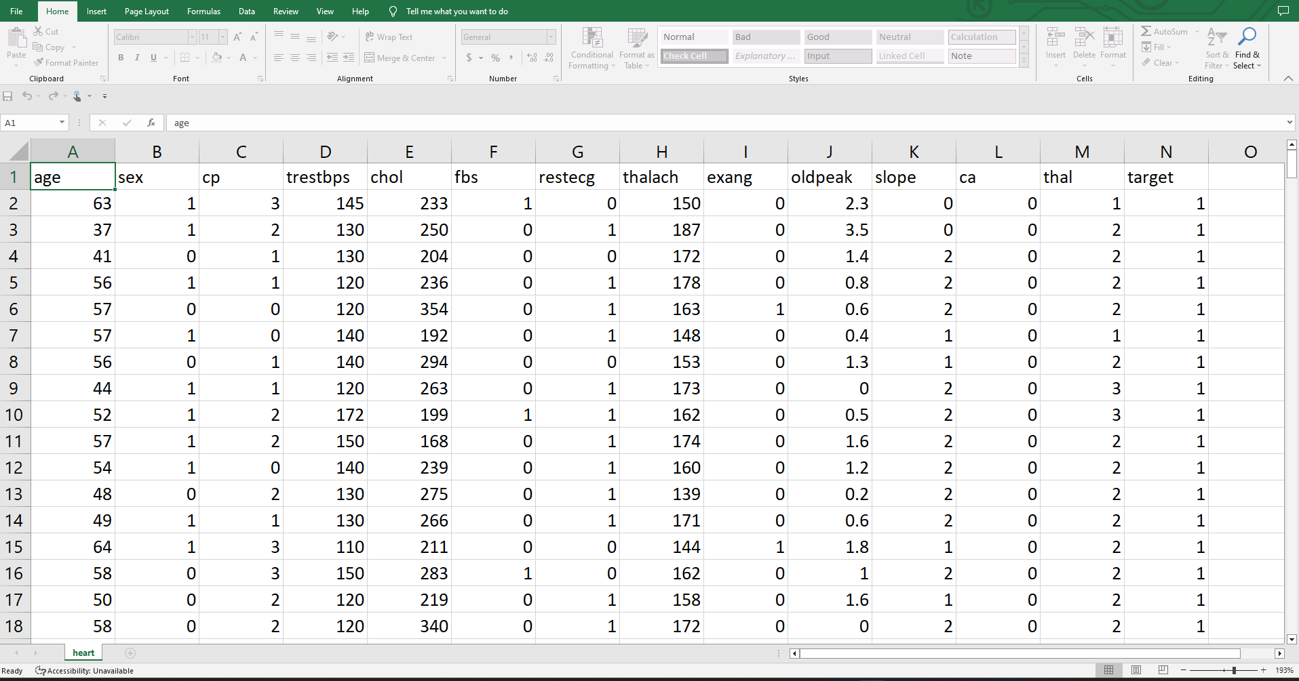

Fig. 2. DATA SET

The data set used in the proposed heart disease prediction model contains various clinical and demographic features of patients that are known to be associated with the risk of heart disease. The data was collected from patients who underwent cardiac testing at a medical center in the United States. The data set consists of 303 samples, with 14 features and 1 target variable.

The 14 features include age, sex, chest pain type (cp), rest- ing blood pressure (trestbps), serum cholesterol level (chol), fasting blood sugar (fbs), resting electrocardiograph results (restecg), maximum heart rate achieved during exercise (tha- lach), exercise-induced angina (exang), ST depression induced by exercise relative to rest (oldpeak), slope of the peak exercise ST segment (slope), the number of major vessels colored by fluoroscope (ca), and the results of the thallium stress test (thal).

The target variable indicates the presence or absence of heart disease in the patient. The presence of heart disease is denoted

by a value of 1, while the absence of heart disease is denoted by a value of 0.

The data set has been prepossessed to handle missing values, remove outliers, and encode categorical variables. The continuous variables have been standardized to have a mean of 0 and a standard deviation of 1 to ensure that each feature is equally weighted in the model.

The data set has been split into training and testing sets with a 80/20 split, where 80 percentage of the data is used for training the model, and 20 percentage is used for testing the model’s performance. This split ensures that the model is evaluated on unseen data and can generalize well to new patients.

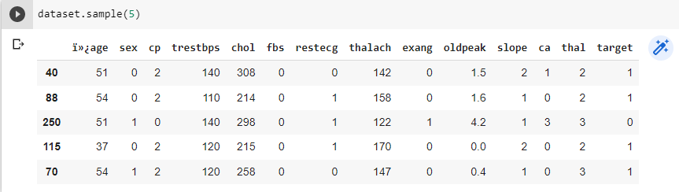

Fig. 3. The dictionary shows the records displayed with head values of the first 5 records from the data set. The bar plot can be used to address the heart disease attributes.

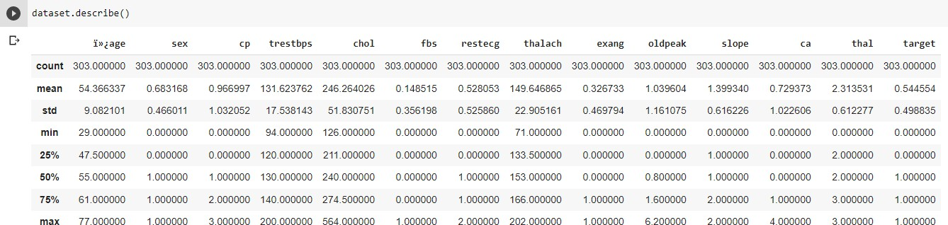

Fig. 4. The describe function describes the count, mean, max, and min statistical reports for the columns of age, sex, cp, chol, and other fields.

The data set has been preprocessed to handle missing values, remove outliers, and encode categorical variables. The continuous variables have been standardized to have a mean of 0 and a standard deviation of 1 to ensure that each feature is equally weighted in the model.

The data set has been split into training and testing sets with a 80/20 split, where 80 percentage of the data is used for training the model, and 20 percentage is used for testing the model’s performance.

1. Results/ Experimentation and

Comparison/Analysis

The testing and training variables are split and passed into the algorithm for heart disease prediction. Keras model of Deep Learning: Keras is a brain network Application Program- ming Connection point for Python that is firmly coordinated with Tensor Stream, which is utilized to construct AI mod- els. Keras models offer a straightforward, easy-to-understand method for characterizing a brain organization, which will then, at that point, be fabricated. Keras is a strong and simple to-involve free open-source Python library for creating and assessing profound learning models. It is important for the

Tensor Flow library and permits you to characterize and prepare brain network models in only a couple of lines of code. Keras Deep Learning working process:

* Data set load
* Keras Model Definition
* Keras Model Compilation
* Keras Model Fit and evaluation.
* Predictions

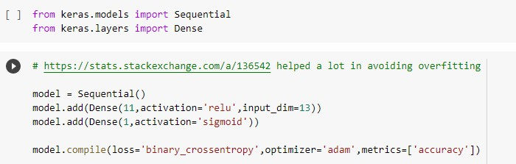

Fig. 5. Evaluation of Keras Model

The possibility of ANNs depends on the conviction that the working of the human cerebrum by making the right associ- ations can be imitated involving silicon and wires as living neurons and dendrites. The human cerebrum is made out of 80 billion nerve cells called neurons. They are associated with other thousand cells by Axons. Upgrades from outside climate or contributions from tangible organs are acknowledged by dendrites. These data sources make electric motivations, which rapidly travel through the brain organization. A neuron can then send the message to another neuron to deal with the issue or doesn’t send it forward.

The accuracy of the neural network is given below:

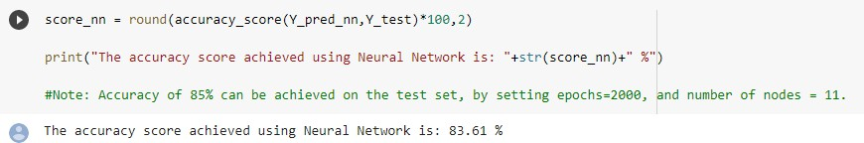

Fig. 6. Preliminary Results

The accuracy of the neural network is given below:

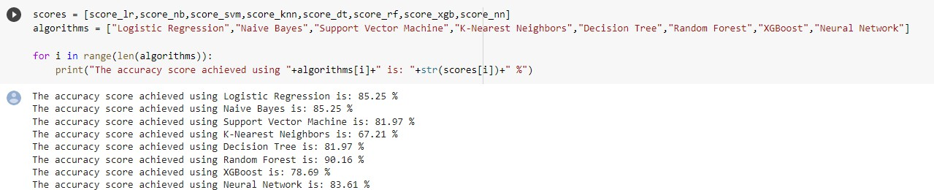

Fig. 7. The final results are compared with different type of algorithm accuracy levels

The accuracy score achieved using the Neural Network algorithm for heart disease prediction is 83.61 percentage. This score indicates that the model is performing well in terms of predicting the presence or absence of heart disease in patients. However, it is essential to compare this score with the scores achieved by other algorithms to get a better understanding of the model’s performance.

Comparing the accuracy scores achieved by various algo- rithms can help determine the most suitable algorithm for this particular data set. The accuracy score achieved using Logistic Regression is 85.25 percentage, which is slightly higher than that achieved by the Neural Network algorithm. The accuracy score achieved using Naive Bayes is also 85.25 percentage, which is identical to the score achieved by Logistic Regression. This indicates that both Logistic Regression and Naive Bayes algorithms are performing better than the Neural Network algorithm for this particular data set.

The accuracy score achieved using Support Vector Machine (SVM) is 81.97 percentage, which is slightly lower than that achieved by the Neural Network algorithm. The accu- racy score achieved using the K-Nearest Neighbors (KNN) algorithm is 67.21 percentage, which is considerably lower than that achieved by other algorithms, indicating that KNN is not suitable for this particular data set. The accuracy score achieved using the Decision Tree algorithm is 81.97 percentage, which is similar to that achieved by SVM. The accuracy score achieved using the Random Forest algorithm is 90.16 percentage, which is the highest among all the algorithms tested, indicating that Random Forest is the best algorithm for this data set. The accuracy score achieved using the XGBoost algorithm is 78.69 percentage, which is lower than that achieved by the Neural Network algorithm.

In conclusion, the Random Forest algorithm performs the best for this data set, achieving an accuracy score of 90.16 percentage. However, the Neural Network algorithm also per- forms reasonably well, achieving an accuracy score of 83.61 percentage. This comparison shows that while the Neural Net- work algorithm is not the best for this particular data set, it is still a viable option for heart disease prediction. Ultimately, the choice of the algorithm depends on several factors, including the data set, available computational resources, and the specific problem at hand.

References

1. Samiul based shuvo 1, shams nafisa ali 1, (student member, ieee), soham irtiza swapnil1, mabrook s. al-rakhami 2, (senior member, ieee), and abdu gumaei “CardioXNet: A Novel Lightweight Deep Learning Framework for Cardiovascular Disease Classification Using Heart Sound Recordings”. February 24, 2021, date of publication March 2, 2021, date of current version March 9, 2021.IEEE.
2. Eun s. lee 1, (member, ieee), byeong g. choi 2, (member, ieee), myung y. kim1, (Member, IEEE), AND SEUNG H. HAN 3, (Member, IEEE)” An

Imbalanced-DataProcessingAlgorithmforthe Prediction of Heart Attack in Stroke Patients”. January 14, 2021, date of publication February 8, 2021, date of current version February 16, 2021, IEEE.

1. Hao ren2,1 aslan b. wong1, wanmin lian3, weibin cheng2, ying zhang1, jianwei he1. “Interpretable Pneumonia Detection by Combining Deep Learning and Explainable Models with Multisource Data” 10.1109/AC- CESS.2021.3090215, IEEE Access.
2. G. Liang and L. Zheng, “A transfer learning method with deep residual network for pediatric pneumonia diagnosis,” Computer methods and programs in biomedicine, vol. 187, p. 104964, 2020.
3. D. Margaritis, “Learning bayesian network model structure from data,” 2003.
4. X.-W. Chen, G. Anantha, and X. Lin, “Improving bayesian network structure learning with mutual information-based node ordering in the k2 algorithm,” IEEE Transactions on Knowledge and Data Engineering, vol. 20, no. 5, pp. 628–640, 2008.
5. S. Watanabe, “A widely applicable bayesian information criterion,” Journal of Machine Learning Research, vol. 14, no. Mar, pp. 867–897, 2013.
6. J. Yao, J. E. Burns, D. Forsberg, A. Seitel, A. Rasoulian, P. Abolmae- sumi, K.Hammernik,M.Urschler,B.Ibragimov,R.Korezetal.,“Amulti- center milestone study of clinical vertebral ctsegmenta- tion,”ComputerizedMedical Imaging and Graphics, vol. 49, pp. 16–28, 2016.
7. H. R. Roth, L. Lu, A. Seff, K. M. Cherry, J. Hoffman, S. Wang, J. Liu,

E. Turkbey, and R. M. Summers, “A new 2.5 d representation for lymph node detection using random sets of deep convolutional neural network observations,” in International conference on medical image computing and computer-assisted intervention. Springer, 2014, pp. 520–527.

1. D. Margaritis, “Learning bayesian network model structure from data,” 2003.
2. H. R. Roth, L. Lu, A. Farag, H.-C. Shin, J. Liu, E. B. Turkbey, and R.M.Summers,“Deeporgan:Multi-level deep convolutionaln etworksfor automatedpancreassegmentation,”inInternationalconferenceonmedical image computing and computer-assiste dintervention. Springer,2015,pp. 556–564.
3. L. Yao, E. Poblenz, D. Dagunts, B. Covington, D. Bernard, and K.Lyman,“Learningtodiagnosefromscratchbyexploitingdependencies among labels,” CoRR, vol. abs/1710.10501, 2017. [Online]. Available: <http://arxiv.org/abs/1710.10501> Learning Research, vol. 14, no. Mar,

pp. 867–897, 2013.

1. “Learning to diagnose from scratch by exploiting dependencies among labels,” arXiv preprint arXiv:1710.10501, 2017.
2. A. Rajpurkar, J. Irvin, K. Zhu, et al. ”CheXNet: Radiologist-level pneumonia detection on chest x-rays with deep learning.” arXiv preprint arXiv:1711.05225 (2017).
3. A. Gupta, A. Jaiswal, S. K. Saha, et al. ”Hybrid intelligent system for pneumonia diagnosis in chest X-ray images.” Computer Methods and Programs in Biomedicine, vol. 198, p. 105741, 2021.
4. H. Li, Y. Gao, L. Xu, et al. ”Deep learning for diagnosis of breast cancer on mammograms: A comparison between transfer learning and image-level training.” Computers in Biology and Medicine, vol. 121, p. 103862, 2020.
5. J. Yuan, J. Li, and H. Li. ”Transfer learning with neural networks for fault diagnosis under different working conditions.” Neurocomputing, vol. 338, pp. 177–189, 2019.
6. L. Li, X. Feng, Q. Zhang, et al. ”A machine learning-based frame- work for predicting survival of patients with lung adenocarcinoma.” IEEE/ACM Transactions on Computational Biology and Bioinformatics, vol. 16, no. 1, pp. 217–227, 2019.
7. T. F. Lang, N. M. M. Somasundaram, M. P. Steinberg, et al. ”Chest X- ray classification using deep learning architectures: A systematic review and meta-analysis.” Journal of Medical Systems, vol. 44, no. 8, p. 146, 2020.
8. Z. Zhang, S. Jiang, and Y. Deng. ”Deep learning for brain tumor segmentation: A comprehensive review.” Neurocomputing, vol. 394, pp. 1–14, 2020.
9. J. Hu, X. Tang, and K. Ma. ”Explainable deep learning for diagnosis of chronic kidney disease using multimodal medical data.” Computerized Medical Imaging and Graphics, vol. 89, p. 101842, 2021.